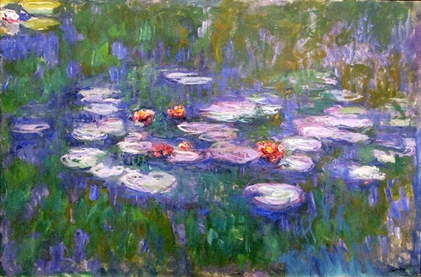
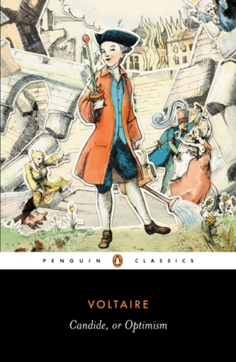
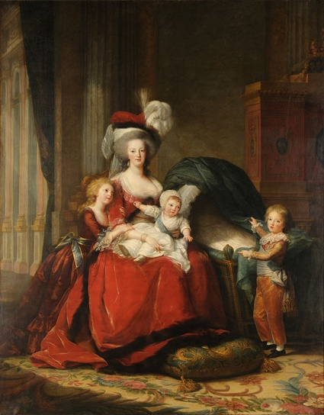

- FIU HONORS COLLEGE FRANCE
LE TOUR DE LA QUESTION : « QU’EST-CE QUE LA FRANCE À DONNEE AU MONDE ET A VOUS-MÊME »
A REVIEW OF THE QUESTION: “WHAT HAS FRANCE GIVEN THE WORLD AND TO YOURSELF”

IDH 4007 Spring (Printemps): Wednesday (mercredi) 1:00 to 3:30 / 13H00- 15H30 January 8th to April 27, 2024
IDH 4008 Summer B in France: Every day while abroad July 1st to July 31st 2024

FACULTY
Amilcar A. Castellano-Sanchez ￭ castelam@fiu.edu ￭ 305-3484390 (OFFICE) ￭ Office Hours by appointment

COURSE DESCRIPTION
This interdisciplinary course examines France’s widespread, sustained and continued influence our individual and worldwide scenarios. Such profound and sometimes unrecognized legacy stems onto political, intellectual, linguistic and cultural portions of our lives.

Students will experience French civilization by learning while on campus about France’s history from its beginning to contemporary times, stressing certain periods that will be experienced first-hand upon out summer visit. We will also visit topics such as society, citizenship, sociopolitical structures, culture, ideologies and through various resources; we will be exposed to art, literature, cinema, music and of course gastronomy.

Based in Paris, the class navigates Francois I’s Renaissance in the Loire castles, Marie Antoinette’s final trek through Paris to the guillotine, and Hemingway’s walk through the streets of the Latin Quarter. Students engage in debates about absolutism, nationalism, revolution, and human rights in the country that saw the most radical, idealistic, and brutal revolution in Europe. They encounter the personalities that have shaped world history–Voltaire, Rousseau, Maximilien Robespierre, Olympe de Gouges, Napoleon Bonaparte, –as well as the figures that revolutionized art history: Pierre Rodin, Monet, Van Gogh, Matisse, and Picasso. The class visits the Louvre, Orsay, Invalides, Sainte-Chapelle, Eiffel Tower, and other museums and monuments of Paris. Included in the program visitation are the castles of the Loire, the beaches of Normandy, the French Alps, Fontainebleau, Versailles, and Lyon.

NOTE: Course content features sexually explicit and/or violent artworks and texts.

Course Objectives: upon culmination of this course, students will:

- Foster the student’s intellectual growth upon exposure to knowledge and concepts and experiences that reflect a different cultural framework and stimulate student’s interest.
- Identify various aspects related to France’s civilization in the domains of arts, music, history, literature, cinema and others.
- Make connections between the French culture, history and civilization and their own culture, history and civilization under the umbrella of globalization.
- Enumerate some of the influences that France’s course topics have in their current life and in the future study abroad experience.
- Critically read and interpret various texts (written and not written) to comprehend France’s influence in the world.
- Evaluate the influence of France’s history and literature towards our history and the world.

MOBILE DATA REQUIREMENT All students are required to have unlimited data for their phones when the group is in Europe. Students can either have an international plan or buy a phone or sim card in Spain. This is matter of safety and efficiency.
Required Resources
For the Spring course you will need dependable Internet access. This is a web-assisted course. While some of the weekly required materials are posted on CANVAS at:
https://canvas.fiu.edu/

REQUIRED TEXTS & FILMS The following required text course materials may be purchased in either print or e-book format. Films are available at either FIU Libraries or Miami-Dade County Public Libraries. Some films will be screened during class time.

Texts:
• Voltaire, Francois. « Candide ». Penguin Classics, 208 pages. 2009. ISBN 9780140455106
- Camus, Albert. “The Stranger”. Penguin Vintage International 123 pages 1989 ISBN 9780679720201
- Rostand, Edmond. “Cyrano de Bergerac” Penguin Classics, ??? pages. 2006 ISBN 9780140449686
- Madame de la Fayette « Princesse de Clèves » Penguin Classics. 192 pages 1992 ISBN 9780140445879
• de Kerangal, Maylis. “The Heart” 256 pages 2017 ISBN 9781250117915

Films
• Cyrano de Bergerac- Film (1990) 2H18. Edmond Rostand. Dir. Jean-Paul Rappeneau. XVII century.
- Moliere – Film (2007) 2H. Dir. Laurent Tirard. XVII Century.
- Joyeux Nöel / Merry Christmas – Film 1H56 Dir. Christian Carion. XX century
- Heal the Living – Film 1H43 Dir. Quillévéré, Katell XXI century
• _“Versailles, Season 1.” Netflix series. Canal+, 2015-2018. Television.

GRADING RUBRIC Each student accrues points over the length of the semester. The final semester point total equals a letter grade based the official FIU grade scale (Note: Please disregard the FIU Canvas percentage).

Grading and Evaluation

Item | Points | Weight (percentage)
Response/Reflection Papers: 4 @ 25 points each | 100 | 25.00
Quizzes (10) on Novels (05) @ 10 points each | 100 | 30.00
Individual Presentation (02) and two question writing (02) 40+10 points each | 100 | 25.00
Museum Based Education MBE (04) | 20 | 7.50
Exams 1 and 2 (30 points or 5.0% each) | 60 | 10.00
In class participation/ attendance and surveys | 20 | 2.50
Total | 400 | 100.00

Grades will be calculated based on percent of total points earned:
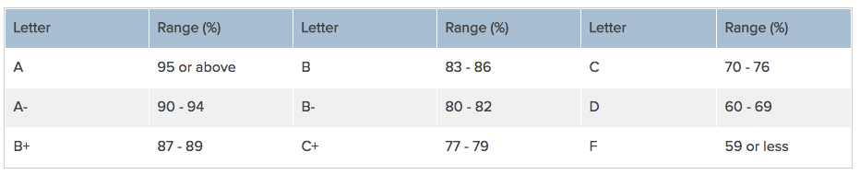

Response papers (RP) (04 @. 25 points each = 100 points 25%): there will be a total of five (04) response papers (RPs) during the semester. All RPs will be assigned via PACKBACK in links posted within CANVAS. These RPs will occur biweekly and will be clearly outlined in the calendar below with an open date, a closing date and specific instructions and resources for each of this RPs. All these RPs are related to the course’s content and course level objectives and will be used as steppingstones to the final response paper, which will combine the ideas and topics discussed within the semester. You are expected to write and one page double-spaced five-paragraph document. Which means, your first paragraph is your introduction where you tell the reader what you are going to be discussing in three main ideas. Each of the three subsequent paragraphs (second, third and fourth) are devoted to one of each three ideas mentioned on paragraph one and your last and fifth paragraph is your conclusion.
MESSAGE TO STUDENTS AND CONTRACT/ESSAY MILL WRITERS The FIU Student Conduct and Honor Code define plagiarism as “The deliberate use and appropriation of another’s work without any indication of the source and the representation of such work as the Student’s own.” Submitting the work of someone else as your own work is plagiarism. This is a serious instance of Academic Misconduct by the student. In Florida, Essay Mill/Contract Cheating sellers are in violation of Florida Statute 877.17: “It shall be unlawful for any person or business entity to sell, offer to sell, or advertise for sale any term paper, thesis, dissertation, essay, or report”
Novels (05):
We will be reading together five novels throughout the semester. We will begin by “Princesse de Clèves” by Madame de la Fayette, then Rostand’s “Cyrano de Bergerac”, followed by “Candide” by Voltaire. “The stranger” by Albert Camus and finalizing with “The Heart” by Maylis de Kerangal. For all these authors and respective genres I will be making a brief introduction.
Quizzes (10) (Total: 10 at 10 points each = 100 points, 30%):
QUIZZES: The ten quizzes will open after each class session and will close the next day by 11:59 PM. Each quiz will stay opened for 20 minutes once started. Quizzes are to be completed before the deadline and within the time allotted. Quiz format questions may include multiple choice questions, short answer responses and / or matching questions.

Individual Presentations (02 per students) : (Presentation 40 points / 02 questions 10 points each = 100 points or 25.00 %): You will be offered a variety of topics / images to present to peers and classmates during the weekly sessions. Topics encompass different themes / artists / movements / disciplines related to the course topics, objectives, or content. Such topics may or may not be related to the material covered in each 16- week (semester) period. You are expected to prepare two presentations that would last 5-7 min and create two pertinent questions per presentation for an in-course assessment. For each presentation, your submission is composed of two items: 1) the presentation file which you will submit to the CANVAS assignment titled “INDIVIDUAL PRESENTATION”, AND the 2) TWO questions that you formulate for an assessment in the course later in the semester; these two questions are also submitted to the respective assignment on CANVAS. The grade will be calculated as an average of your faculty’s grading. The rubric and criteria will be available through the assignment page in CANVAS.
Museum based activities (04) 30 points 7.50%): There will be several visits to our PPFAM on campus as noted on the class schedule. These sessions are considered of paramount importance as they would help increase your communication and observational skills, verbal and non-verbal communication, your listening and writing skills as well as some manual dexterities. These visits will be co-led by a museum Educator, Prof Machado and your professor, however, all these sessions demand active student participation.
In class Participation, Attendance and survey completion 10 points 2.5%:

- In class Participation: There are many faculty members participating in this course, and as a result, not only many different teaching styles, but also many ways of assessing your mastery of the material. You are expected to be an active participant in class presentations and discussions in class and on the boards through CANVAS as well as completion of two learning journal entries. To participate, you must be there, so attendance is mandatory. Tardiness to class sessions will be addressed on individual bases if necessary. Should something arise, you are allowed two (02) excused absences. However, please keep in mind that it will not be possible to make up grades for missed presentations, class participation, or for missed quizzes.
- ATTENDANCE: Three unexcused absences will result in a decrease of one letter grade. Four or more unexcused absences will result in a course grade of ‘F.’ please also keep in mind that this course is designed for you—the future health professional. It is important that you maintain the highest ethical conduct and professionalism in your academic and personal life to be successful in attaining your future goals. If any problems should arise, please contact Dr. Castellano-Sanchez
Netiquette (https://online.fiu.edu/html/canvas/policies/)

Tentative Calendar for IDH 4001: Spring 2024- WEDNESDAYS 1:00 to 3:30 PM ???????
DISCLAIMER: SESSION OBJECTIVES, ACTIVITIES, LINKS TO VIDEOS AND DETAILS PER WEEK WILL BE POSTED TO EVERY WEEK WITHIN CANVAS
Class Meeting
Reflection papers (RP)
Quizzes or Discussion boards (DB)
Exam
Museum Based Education
Individual Presentations
Holiday No class

Week  Date | Topic (Faculty) | In class activities | Links | Planning ahead
1  Jan 10 | Course Introduction  Syllabus review  Canvas site review  Individual Project assignation (AC) | - Professor presentation  - Student introductions  - Syllabus review  - Canvas review  - Individual topic dates / topic decisions
 | History of France | Certain remarkable figures:  - Vercingetorix: the myth of a resistant hero  - Charlemagne: the birth of France  - Jean of Arc: patriot’s defender  - Henri IV: in defense of intellectual and religious freedom  - Louis XIV: centralization of power  - Napoleon I: power centered towards services and equalitarian reforms

2  Jan 17 | History of France | -Pre History: Lascaux  -Antiquity: the Roman remains  - Middle Ages; Gothic Cathedrals

- Renaissance: Loire valley castles

- XVII century: Versailles

- XVIII century: openings to a new world

- XIX: Trains stations and civil monuments

- XX: Squares, cities and expansion activities
3  Jan 25 | History of France  Institutions  National identity | - The Republic and political parties  - The Presidents’ Republic  - Defining a new relation with the Government  - Choosing for Europe
 |  | - National Symbols: Flag, National Anthem, National Missive, La Marianne
4  Feb 01 | Society, citizenship, politics | - The Republican Model  - History and Memory
- The role of women
- Immigrants in France
5  Feb 8 | Culture: figures, government and culture, diversity | - Figures of the cultural arena  - The Cultural State  - The cultural spaces
- Cultural practices
- Cultural industry
- Cultural diversity: a combat.
6  Feb 15 | Ideals: intellectuals, prominent thinkers and new philosophers | - XVI century: Humanism  - XVII century: Cartesians  - XVIII century Enlightenment (Lumières)  - XIX century: socialism  - XX century: existentialism

- Intellects, Engagement and Opinion

- Enlightenment period and its thinkers

- Main contemporary thinkers: Sartre, Beauvoir and Camus.

- New philosophers
7  Feb 22 | Literature: an overview: novel, caricature, francophone literature and poetry | - The Novel (experimental, psychologic and social tradition)  - “Noveau roman”  - New clasiques  - The place of the writer  - The Autobiography

- Graphic novels – Comics

- Francophone literature

- Poetry
8  Mar 1 | SPRING BREAK  No class

Vacances du Printemps

Pas de classes
9  Mar 8 | Literature: an overview: novel, caricature, francophone literature and poetry | - Continuation
10  Mar 15 | Art and Literary Movements French Paintings | - Baroque  - Classicism  - Rationalism , Rococo and neo-classicism  - Romantism
11  Mar 22 | French Paintings | - Realism  - Symbolism  - Modernism
12  Mar 29 | Theater, dance | - Author driven theater  - Director driven theater  - Classical dance tradition  - Contemporary dance
13  Apr 5 | Music | - Classical music; from Debussy to Milhaud  - Contemporary music from Messiaen to Boulez
 |  | - Francophone Music though the world
14  Apr 12 | Travelling to France: do’s and don’ts
15  Apr 19 | Travelling to France: Planning ahead

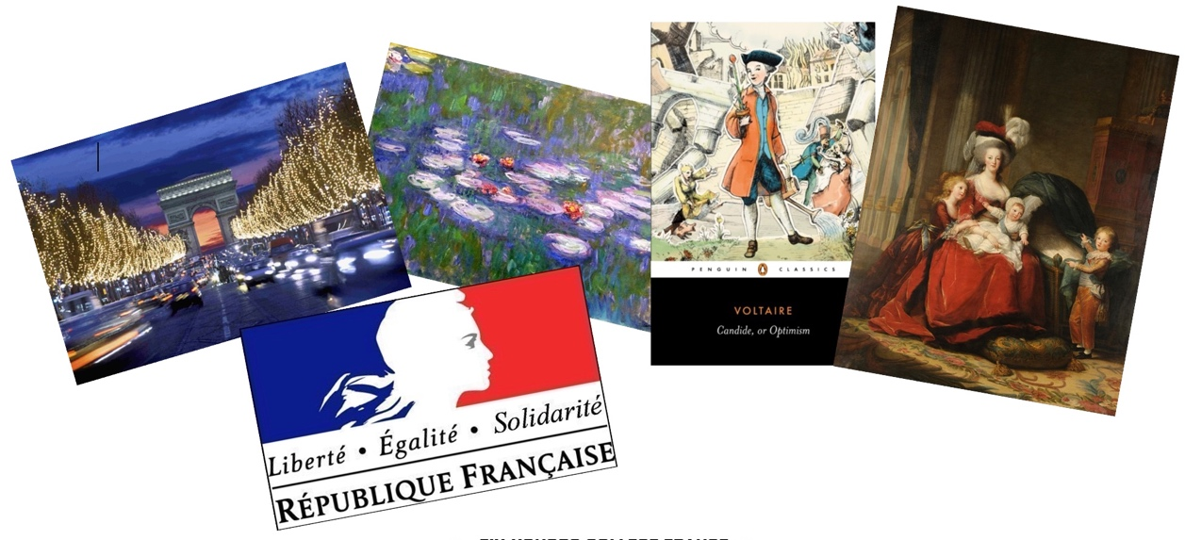

Summer B 2024 in France: Every day while abroad July 1st to July 31st 2024

Course Objectives: upon culmination of this course, students will:

- Foster the student’s intellectual growth upon exposure to knowledge and concepts and experiences that reflect a different cultural framework and stimulate student’s interest.
- Experience various aspects related to France’s civilization in the domains of arts, music, history, literature, cinema and others.
- Re-define and evaluate connections between the French culture, history and civilization and their own culture, history and civilization under the umbrella of globalization.
- Confirm some of the influences that France’s course topics have in their current life and in the future study abroad experience.
- Critically read and interpret various texts (written and not written) to comprehend France’s influence in the world.
- Experience the influence of France’s history and literature towards our history and the world.
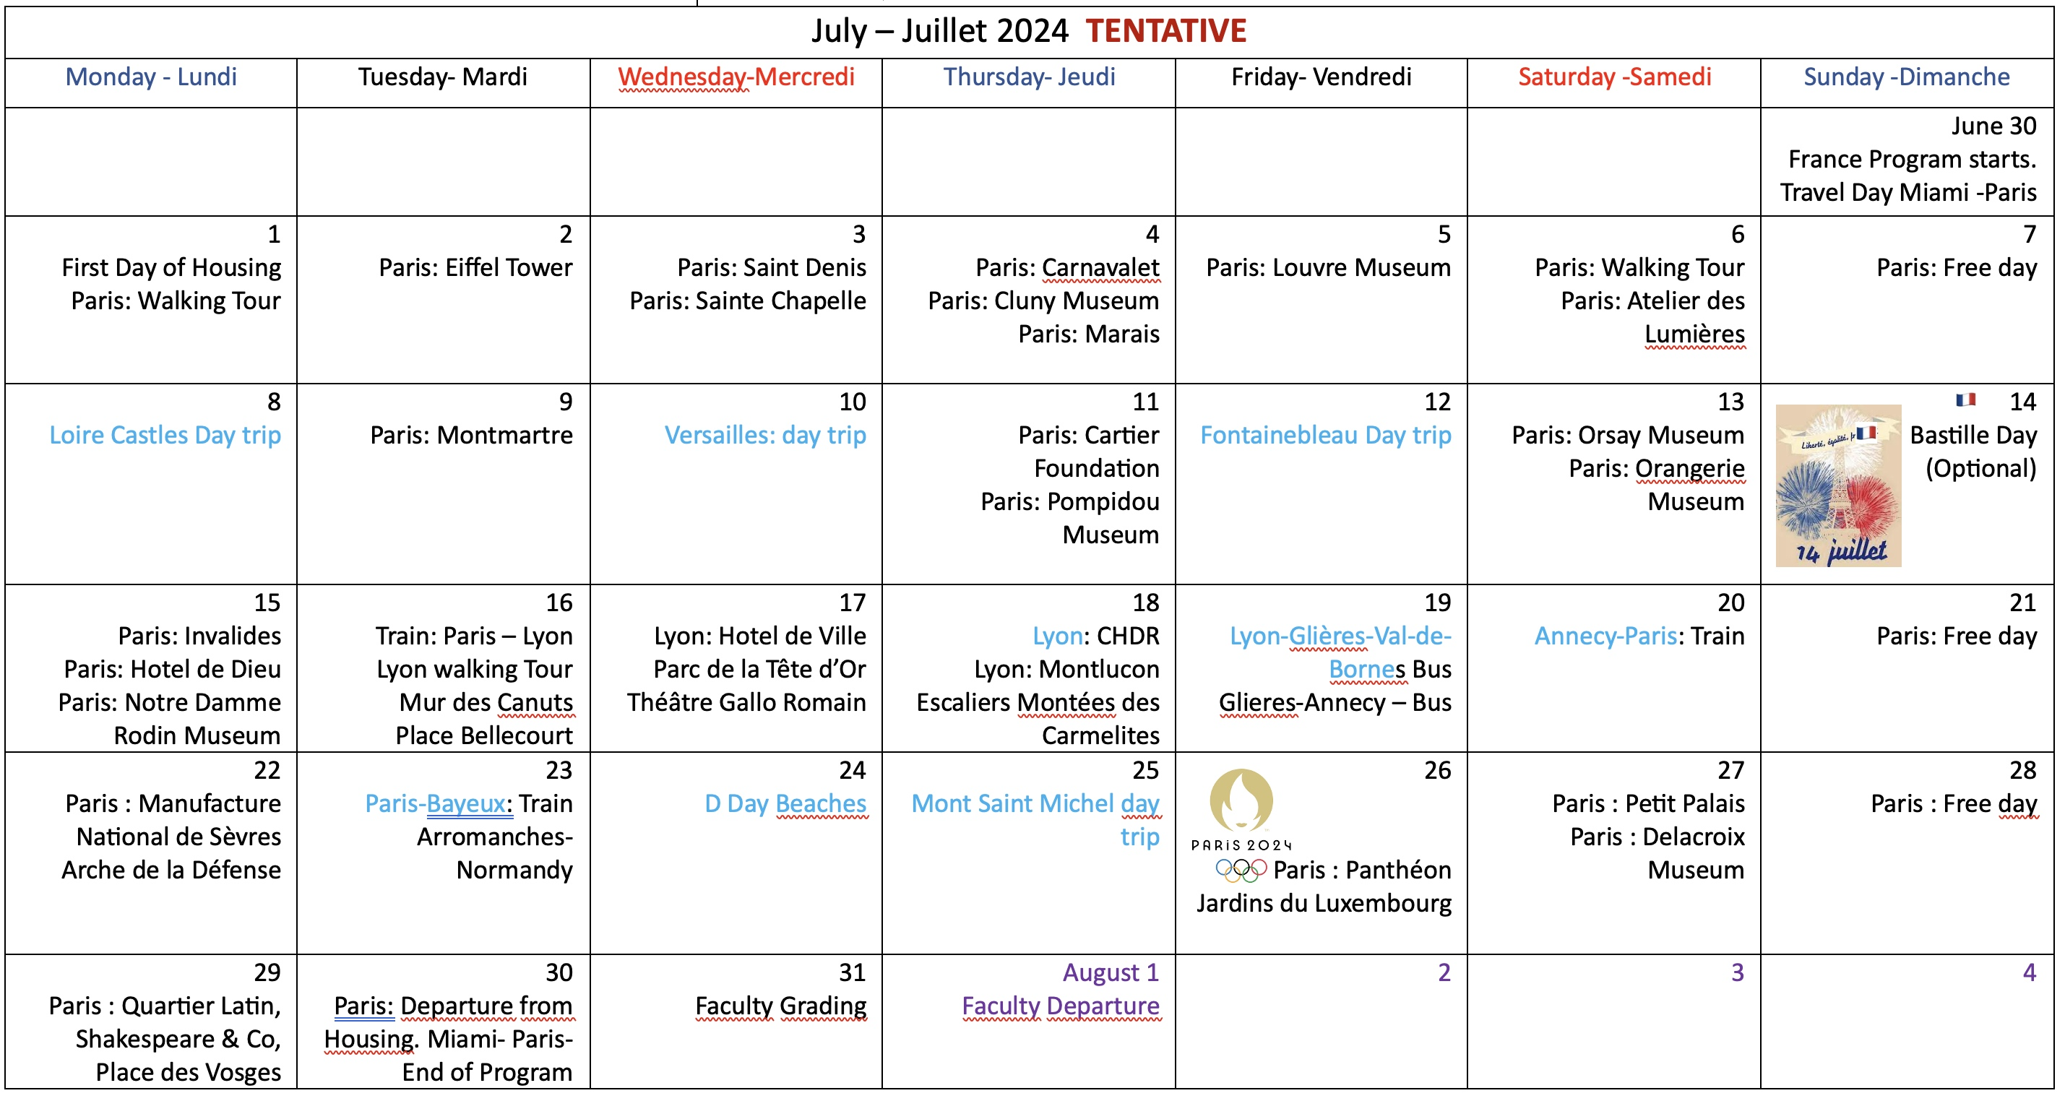

Grading and Evaluation

Item | Points | Weight (percentage)
Short Response Papers (sRPs) : 18 @ 10 points each | 180 | 36.00
Individual Presentation (02) and two or more trivia question 50 points each | 100 | 25.00
In class participation/ attendance and surveys | 220 | 44.00
Total | 500 | 100.00

Short response papers (sRP) (18 @. 10 points each = 180 points 25%): there will be a total of ?? (??) short response papers (RPs) during the semester focused to the experience abroad. All these sRPs will be assigned via Canvas and Turnit in. Such sRPs will occur throughout our stay and will be clearly outlined in the calendar within Canvas with an open date, a closing date and specific instructions and resources for each of these sRPs.
All these sRPs are related to the in country France experience and build from the material learnt during the Spring introductory course. Most of these sRPs will include a written response coupled with some creative component in the form of an image (picture, photograph, design, etc.). You are expected to write and one page double-spaced five-paragraph document. Which means, your first paragraph is your introduction where you tell the reader what you are going to be discussing in three main ideas. Each of the three subsequent paragraphs (second, third and fourth) are devoted to one of each three ideas mentioned on paragraph one and your last and fifth paragraph is your conclusion; identical to what you were asked to contribute in the Spring semester.
- Topic: “You are going to France” Why are you embarking in this experience? What motivates you to do this? Why France? What image or perception do you have of the country now? Which are your expectations? What are you most looking forward to visit? Why?
- Topic: “You arrived in France” Tell us about that experience, your arrival, the airport, immigration, what was your first impression? Did you grab a bite? What? Why? How was it?
- Topic: “The Seine River experience” Exploring Paris since yesterday, what you find that is unexpected, good or bad. The Seine river and its unique bridges, how is that a statement to the city’s layout? Right or Left any side better. Is that just a geographical concept?
- Topic: « La fille ainée de l’Eglise » Among the places you saw today, you visited two main Cathedrals in Paris. There are many more representing not just Catholicism but other religions. How does the topic relate to the visit today? Show with one image why this is a “nickname” of Paris.
- Topic: Choose one! From the three visits, you made today (Carnavalet, Cluny Museum or Le Marais) pick one and share how that place shows the “French spirit” in your opinion. Be sure to include an image.
- Topic: How does art relates to you: in these few days and from previous experience, you have seen how important and disseminated art is in France. Thus far, in this initial exposure, comment on how does art relates to you and be sure to include if that relation has changed since you arrived.
- Topic: « Les châteaux de la Loire » Upon visiting a few of the castles in the Loire valley you may have a deeper understanding of the history and civilization of France. What did you find surprising? What is certainly unique? Can you draw any parallels between that experience and anything you have experienced at home?
- Topic: « Oh la, la… Montmartre! » It is possible one if not the most unique « arrondissements » in Paris. What can you tell us about the experience? Anything you learned, anything you want to see again, anything you did not enjoy, explain your responses.
- « Le château de Versailles » If you can keep yourself to one page, please share about a moment, a space, an image, a portrait, a room, a story, whatever was that made you “shiver” or impressed you the most.
- Topic : « Orsay, L’Orangerie le quel ? » Upon this superb exposure to art you have been in front of magnificence, it is Rodin, les nénuphares by Monet, Manet, Millet, Lhermite and so many more, Upon this “intoxication” tell us what it made you feel or think personally or professionally, or as it relates to your experience thus far in France.
- « Bastille Day » how was it? What did you see? How does this day relate to France’s history? Which are the consequences of such day?
- Lyon, Glières-Val-de-Bornes, Annency : and your favorite was? Share with us why, how, what it make you feel or think about.
- Topic: “and why another arch?” Elaborate on your thoughts about the question. Explain your response, compare and contrast.
- Topic WW-II, resistance, D-Day: Share about something you learned during this field trip.
- Topic « Le Petit Palais et Delacroix » : Is the « petit » palace that small ? Did you know anything about Delacroix, what is new and exciting after these two visits?
- Topic « Le Quartier Latin. L’Institute du Monde Arabe » : Latin ? Why so? The Arab world in the middle of Paris? Choose one and share what you learn.
- Topic: Ready to go back home ? We are going back. Share about this experience. Anything that feels important.
- Topic: My time in France. Is “your” France now the same, better or worse as the construct you had before coming?
Individual Presentations (02 per students) : (Presentation 50 points each = 100 points or 25.00 %):
Two short presentations are required from you: Topics are “France in my eyes” and “The best French bite”. You are expected to prepare two presentations that would last 5-7 min and create two or more pertinent trivia questions per presentation for an in-course assessment.
For each presentation, your submission is composed of two items: 1) the presentation file which you will submit to the CANVAS assignment titled “France in my eyes” and “The best French bite” including TWO or more trivia style questions that you formulate based on your current experience. The rubric and criteria will be available through the assignment page in CANVAS.
In class Participation, Attendance and survey completion 220 points 44%:

- In class Participation: There are many faculty members participating in this course, and as a result, not only many different teaching styles, but also many ways of assessing your mastery of the material. You are expected to be an active participant in class presentations and discussions in class as well as completion of two learning journal entries. To participate, you must be there, so attendance is mandatory. Tardiness to class sessions will be addressed on individual bases if necessary. Should something arise, you are allowed two (02) excused absences. However, please keep in mind that it will not be possible to make up grades for missed presentations, class participation, or for missed quizzes.
- ATTENDANCE: Three unexcused absences will result in a decrease of one letter grade. Four or more unexcused absences will result in a course grade of ‘F.’ please also keep in mind that this course is designed for you—the future health professional. It is important that you maintain the highest ethical conduct and professionalism in your academic and personal life to be successful in attaining your future goals. If any problems should arise, please contact Dr. Castellano-Sanchez

Honors College Policies and Requirements

Academic Misconduct Procedures and Policies
In The Honors College, the term “honor” refers both to academic accomplishment and character. Students in Honors should therefore adhere to and be held to the highest standards of personal academic accountability. Academic dishonesty in any form, including plagiarism, is antithetical to the very definition of being an Honors student at FIU. Consequently, an Honors College student found responsible for academic misconduct will be dismissed from the College.
An Honors faculty member may bring charges of academic misconduct against an Honors student if the faculty member suspects plagiarism or other forms of academic misconduct. The faculty member will decide whether to pursue informal resolution, file formal resolution charges, or take no further action, and will follow the procedures outlined in the Academic Misconduct Procedures available at https://studentaffairs.fiu.edu/get-support/student-conduct-and-academic-integrity/academic-integrity/index.php . Please refer to the following documents for additional information:
FIU Student Handbook: https://studentaffairs.fiu.edu/about/student-handbook/index.php

Honors Engagement Requirements
In The Honors College we strive to build a sense of community, the kind you get at a small liberal arts college, but with all the resources of a major public university. Our events, workshops, and activities are all designed with the purpose of enriching your life and giving you an experience that transcends mere classroom learning. We hope that you will take advantage of all these opportunities to learn and grow. Your 11-activity HC Engagement Pathway and 20 volunteer hours will be tracked using Panther Connect and Give Pulse, respectively. Make sure to login and create your profile for both systems. Don’t forget to read your weekly Next Week in Honors newsletter for awesome opportunities! It lands in your FIU Inbox every Friday. See Engagement and Community Service for more information.

Religious Observances
Every effort will be made, where feasible and practical, to accommodate students whose religious practices coincide with class
requirements or scheduling. Please make sure to notify your instructor at the beginning of the semester of which dates you will be absent or any anticipated problems with completing course work.

Physical, Mental and Sensory Challenges
Every effort will be made, where feasible and practical, to accommodate students who are so challenged. Should you require accommodations, contact the Disability Resource Center, if you have not done so already.

Resources:
Panthers Care & Counseling & Psychological Services
If you are looking for help for yourself or a fellow classmate, Panthers Care encourages you to express any concerns you may come across as it relates to any personal behavior concerns or worries you have, for the classmate’s well-being or yours; you are encouraged to share your concerns with FIU’s Panthers Care website.
Counseling and Psychological Services (CAPS) offers free and confidential help for anxiety, depression, stress, and other concerns that life brings. Learn more about CAPS at caps.fiu.edu. Professional counselors are available for same-day appointments. Don’t wait to call 305-348-2277 to set up a time to talk or visit the online self-help portal.

