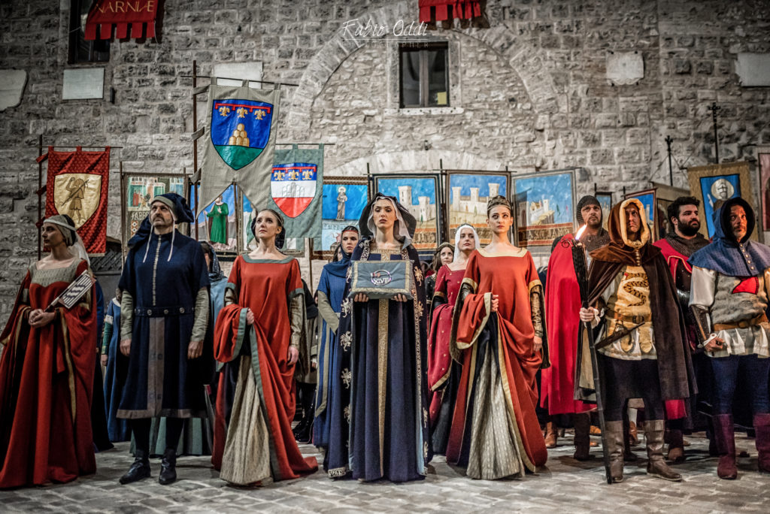

Syllabus Gran Tour of Italy
IDH 4007 (Spring) and IDH 4008 (Summer A)
Spring: Wednesdays 2:00pm-4:15pm
Summer: Every day while in Italy

Faculty: Magda Novelli Pearson – pearsonm@fiu.edu – Office Hours by appointment

Course Description

The Grand Tour was a traditional trip through Europe for the upper class. The custom of embarking in this educational journey, started in the 17th century and lasted for centuries.
Italy was the key destination of the Grand Tour. Nowadays Italy is still one of the most visited countries in the world and during our study abroad you will find out why.
You will step into the past to better understand the present, you will be wondering in the arena where gladiators were fighting for their freedom, you will be touched by the lives destroyed by a sudden eruption in Pompei, you will be overwhelmed by architectonical beauty and timeless art.

Students will also reflect on how tourism has been changed in the last 300 years. Men have been traveling near and far since the antiquity, feeding the human desire of discovery, but the Grand Tour will start a new concept of tourism that is still lasting nowadays. Traveling in the course will expand the students’ awareness and understanding of multicultural perspectives. In order to acquire the necessary knowledge of Italian culture and traditions before traveling in Italy during Summer A, students will be exposed to virtual Italy through Google Arts & Culture App.

Course Prerequisites: None

Course Materials:

- VR Goggles for iPhone (from $8 on Amazon)
- Extracts form the following books
J.W. Goethe. Italian Journey: 1876-1878. Penguin Classic. 1992. ISBN 978-0140442335
Mark Twain. The Innocents Abroad. Penguin Classic. 2011. ISBN 978- 023489076
Luigi Barzini. Italians. Penguin. 1991. ISBN 978-0140145953
Beppe Servegnini. La bella figura: A field guide to the Italian mind. (Any edition)
- Movies
Room with a view by James Ivory, 1985
The Talented Mr. Ripley by Antony Minghella, 1999
Gladiator by Ridley Scott, 2000
- All the content in Grand Tour of Italy in the Arts & Culture Google App

Students Learning Outcomes:

- Demonstrate a general understanding of cultural, social, and historical realities of Italy
- Apply critical readings skills in analyzing and debating cultural, geographical, and artistic expressions
- Interpret and analyze works of literature
- Recognize cultural diversity
- Design/create their own interactive virtual educational travel abroad tours with immersive technology

Grading:

Spring 2024: Summer 2024:

4 Quizzes ………….30% 4 Quizzes (multiple choice on Canvas) …. 30%
Discussions* and Participation**…30% Discussion, Participation (class time in Italy) 40%
Attendance*** …25% Attendance is mandatory
1st part of the Project (create your story on Google Earth) **** 15%. Final Project (Create your story on google Earth) 30%

*Those are weekly topics posted on Discussion (Canvas) about readings, movies, and VR material students will discuss and comment in class. Assessment Rubric posted in Canvas.
**Participation: Class participation will be judged on the basis of quality and consistency of effort on daily basis. Attendance is NOT participation. Each student can ascertain the adequacy of his/her participation by occasional discussion with the professor.
*** Attendance: Regular attendance is mandatory. Students may be absent from class 2 times with no penalties. 2 points will be deducted per absence from the final grade for all other absences.

Tardiness: For every 3 times you arrive late (more than 10 minutes) or leave early, it will count as 1 absence.
It is your responsibility to be in class on the day of a quiz. NO make-ups are allowed unless you have a legitimate written excuse signed and dated from a reliable source regarding a personal or family emergency: i.e., doctor, hospital, accident report, family death notice, and /or court appearance.
**** The presentations will take place during the last week of the Spring semester. Students can choose to work in small groups (max 2 per group) or by themselves. Using Google Earth add placemarks of all the places we will visit in Italy (see course calendar Summer A in Canvas) and the ones that you intend to visit during your free time. Add pics of places you can find online and explain why you would like to visit them. The second and final part of the project will be due by the end of Summer A. You will be replacing the pics you found online with the ones you took during the trip, and you will write a brief text of explanation for each pic telling your Italian journey.
Open this link for instructions:
Create Your Story Instructions
Creativity and originality will be rewarded!!!

Classroom Policies:
- Students are expected to conduct themselves properly with respect for the instructor, other students, and themselves.
- If you are absent, contact a classmate to share notes about what you missed in class.
- Unless you are an undercover superhero who has to save the world, make sure that:
Your cell phone is in your pocket and NOT on the desk in front of you or in your hands; your pc is actually “tuned” on the class topic, and you are not doing something else during our class time.
- Do not leave early and do not arrive late. It is very annoying and disrupting for the class.

Grading scales:
A | 100-94 | C+ | 79-77
A- | 93-90 | C | 76-70
B+ | 89-87 | D+ | 69-67
B | 86-84 | D | 66-64
B- | 83-80 | D- | 63-60

Spring 2024 Course Calendar:

Module 1- The Grand Tour of Italy: The Voyage Begins

Getting familiar with VR and Google App

Reading: Italian Journey + Class Discussion (see Canvas for topic: How Tourism hasn’t chaged since the Grand Tour)

Explore (VR): Grand Canal of Venice

Explore with Street View: Ponte dei Sospiri and San Marco Square

Read and Discuss: From San Marco to the Moon (How Galileo started a cultural revolution from Piazza San Marco)

Read and Discuss: Canaletto’secrets (How Canaletto paintings have been used to fight the “acqua alta in Venice”)

1st Class Field Trip on September 8 : FIU Frost Museum Exhibit: Allegories for Learning
16th to 18th-Century Italian Works on Paper from the Georgia Museum of Art

1 Quiz

Module 2 - The Renaissance

Explore (VR) : Home of the Palio (Piazza del campo Siena)

Explore with Street View : Piazza del Campo

Read and Discuss: Siena, the city of Networking ( the craddle of the first social media)

Explore (VR): Uffizi Museum

Explore with Street View: Ponte Vecchio and Piazza della Signoria

Watch: Room with a View

Read and Discuss: Innocents Abroad

Explore: Pienza the Ideal city of Renaissance

2nd Class Field Trip: Vizcaya Museum and Gardens (Date TBA)

2nd Quiz

Module 3 – The Eternal City

Explore (VR): Birthplace of public art (Piazza del campidoglio in Rome)

Explore with Street View: Spanish Steps and Pantheon

Read and Discuss: Rome the first Social Network

Read and Discuss: Italians

Explore (VR): A World Without Art (How an Italian idea unlocked art for everyone)

Explore (VR): Rome: World Heritage

Explore in Street View (VR): Piazza Di Spagna and Fontana di Trevi

Watch: Gladiator

3rd Quiz

Module 4 – Deconstructing Stereotypes

Read and Discuss: La bella figura. A field guide to the Italian mind

Watch: The Talented Mr. Ripley

Explore (VR): Air Conditioning in the Middle Age

Explore (VR): Street Food Before It Was Cool

Explore (VR): Teatro Massimo, Palermo: Italy’s Largest Opera

Reflect and Analyze: What do the Gap Year and the Grand Tour have in Common?

Reflect and Analyze: After our virtual Grand Tour, do you agree with Lamartine’s verses about Italy: "land of the past... where everything sleeps."?

3rd Field Trip: Pasta Making Cooking Class (Date TBA)

4th Quiz

Module 5 – Projects Presentations

We’ll watch in class students’ projects and discuss them.

Summer 2024 Course Calendar

Please refer to Daily Trip Calendar on Canvas

Religious Observances
Every effort will be made, where feasible and practical, to accommodate students whose religious practices coincide with class requirements or scheduling. Please make sure to notify your instructor at the beginning of the semester of which dates you will be absent or any anticipated problems with completing course work.

Physical, Mental and Sensory Challenges

The Disability Resource Center collaborates with students, faculty, staff, and community members to create diverse learning environments that are usable, equitable, inclusive, and sustainable. The DRC provides FIU students with disabilities the necessary support to successfully complete their education and participate in activities available to all students. If you have a diagnosed disability and plan to utilize academic accommodations, please contact the DRC at 305-348-3532 (MMC) or at 305-919-5345 (BBC) to schedule an appointment. You can also visit them in person in GC 190 at MMC or in WUC 131 at BBC campus.

Honors College Policies and Requirements Academic Misconduct Procedures and Policies

In The Honors College, the term “honor” refers both to academic accomplishment and character. Students in Honors should therefore adhere to and be held to the highest standards of personal academic accountability. Academic dishonesty in any form, including plagiarism, is antithetical to the very definition of being an Honors student at FIU. Consequently, an Honors College student found responsible for academic misconduct will be dismissed from the College. An Honors faculty member may bring charges of academic misconduct against an Honors student if the faculty member suspects plagiarism or other forms of academic misconduct. The faculty member will decide whether to pursue informal resolution, file formal resolution charges, or take no further action, and will follow the procedures outlined in the Academic Misconduct Procedures available at https://studentaffairs.fiu.edu/get-support/student-conduct-and-academic-integrity/academicintegrity/index.php .
Please refer to the following documents for additional information: FIU Student Handbook: https://studentaffairs.fiu.edu/about/student-handbook/index.php

Student Portfolios
The Honors College will be using a portfolio method to assess students’ learning outcomes. The portfolio allows for maximum flexibility in gauging student learning. Students decide (with instructor consultation) what “artifacts” or assignments to include for consideration in their portfolios to demonstrate successful achievement of each of five key student learning outcomes over the 4-year Honors experience. Portfolios provide a rich context for students to show what they have learned and to explain their learning process. Because the Honors curriculum is meant to be thought-provoking and reflective, student self-assessment through portfolios will facilitate learning and provide in-depth assessment. Each Honors College course includes at least one assignment that could potentially fit portfolio requirements. http://honors.fiu.edu/current-students/portfolio/

Honors Engagement

Requirements Honors College students are required to accumulate at least 20 engagement points each academic year (Fall and Spring) by attending Honors College activities. Students attending only one semester (Fall or Spring) are required to accumulate 10 engagement points. Each activity has a point value. Students may select which events and activities they want to attend. The new system is designed to be more flexible for students, offering events at various days and times (including some weekend events) and allowing for a variety of ways to meet the requirements. Please plan accordingly. http://honors.fiu.edu/current- students/citizenship/

Community Service

Honors College students must also complete 20 volunteer service hours. These hours DO NOT count toward the 20 engagement points discussed above. http://honors.fiu.edu/current-students/communityservice/

Honors Education in the Arts (HEARTS)

The HEARTS program is designed to give Honors College students opportunities to “explore and appreciate different artistic and cultural traditions and modes of artistic expression. HEARTS will also serve as a clearinghouse (and curatorial framework) for our students to experience the arts on campus and in the community by providing them with information about cultural activities and access to performances with free or discounted tickets. http://honors.fiu.edu/current-students/hearts/

